ASSIGNMENT – 04

- Given a network address of 192.168.10.0/24, divide it into 4 equal subnets and write down the subnet mask, network address, and broadcast address for each subnet.

Subnetting: Divide 192.168.10.0/24 into 4 Equal Subnets
Step 1: Calculate the new subnet mask
- Original network: 192.168.10.0/24
- Required subnets: 4
- Bits borrowed: 2^2 = 4, so borrow 2 bits.
- New CIDR prefix: /24 + 2 = /26
- New subnet mask: 255.255.255.192
Step 2: Calculate the block size
text{Block Size}=256-192=64
Therefore, the subnet network addresses increase by 64.
Step 3: Subnetting table
Subnet | Subnet Mask | Network Address | Broadcast Address
1 | 255.255.255.192 (/26) | 192.168.10.0 | 192.168.10.63
2 | 255.255.255.192 (/26) | 192.168.10.64 | 192.168.10.127
3 | 255.255.255.192 (/26) | 192.168.10.128 | 192.168.10.191
4 | 255.255.255.192 (/26) | 192.168.10.192 | 192.168.10.255

- For one of the subnets you created, assign valid IP addresses to 5 devices (such as a router, two laptops, a printer, and a mobile) and list which IP goes to which device.<br><br><em><strong>Hint:</strong> Make sure not to use the network or broadcast address for any device.</em>

IP Address Assignment for 5 Devices
Selected subnet: 192.168.10.0/26
- Subnet Mask: 255.255.255.192
- Network Address: 192.168.10.0
- Broadcast Address: 192.168.10.63
- Valid Host Range: 192.168.10.1 – 192.168.10.62
IP Address Assignment Table
No. | Device | Assigned IP Address | Subnet Mask
1 | Router | 192.168.10.1 | 255.255.255.192
2 | Laptop 1 | 192.168.10.2 | 255.255.255.192
3 | Laptop 2 | 192.168.10.3 | 255.255.255.192
4 | Printer | 192.168.10.4 | 255.255.255.192
5 | Mobile | 192.168.10.5 | 255.255.255.192

- Draw a simple diagram (hand-drawn or digital) showing your subnet plan: label each subnet, the range of IPs, and where each device is connected.

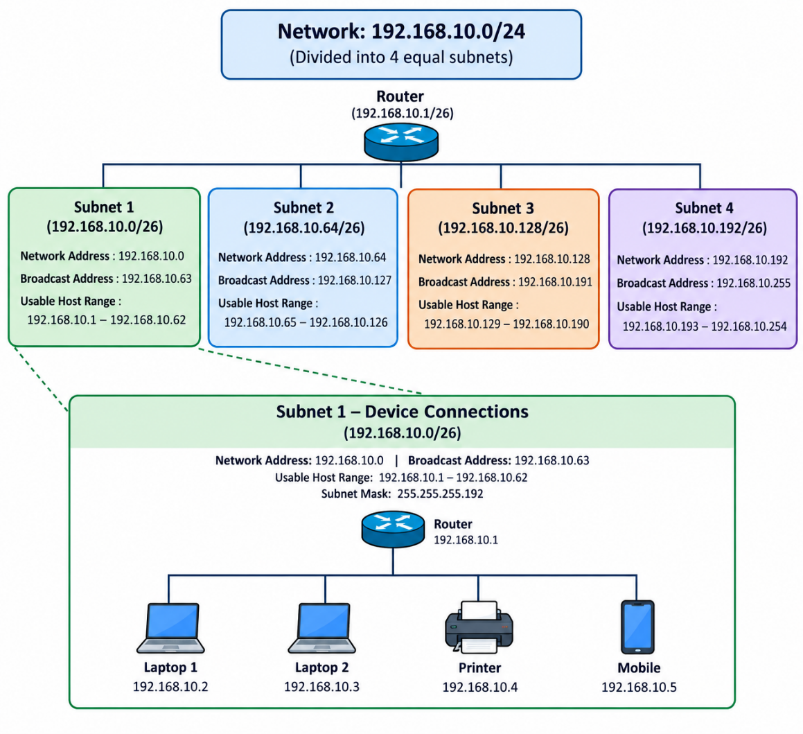

- Document step-by-step how you calculated the subnet mask, number of hosts per subnet, and assigned IP addresses for your plan, as if you are explaining it to a friend who is new to subnetting.

Item | Final Answer
Original Network | 192.168.10.0/24
New CIDR Prefix | /26
New Subnet Mask | 255.255.255.192
Bits Borrowed | 2
Total Subnets Created | 4
Total IP Addresses per Subnet | 64
Usable Hosts per Subnet | 62
Block Size | 64
Selected Subnet | 192.168.10.0/26
Network Address | 192.168.10.0
Broadcast Address | 192.168.10.63
Usable Host Range | 192.168.10.1 – 192.168.10.62

